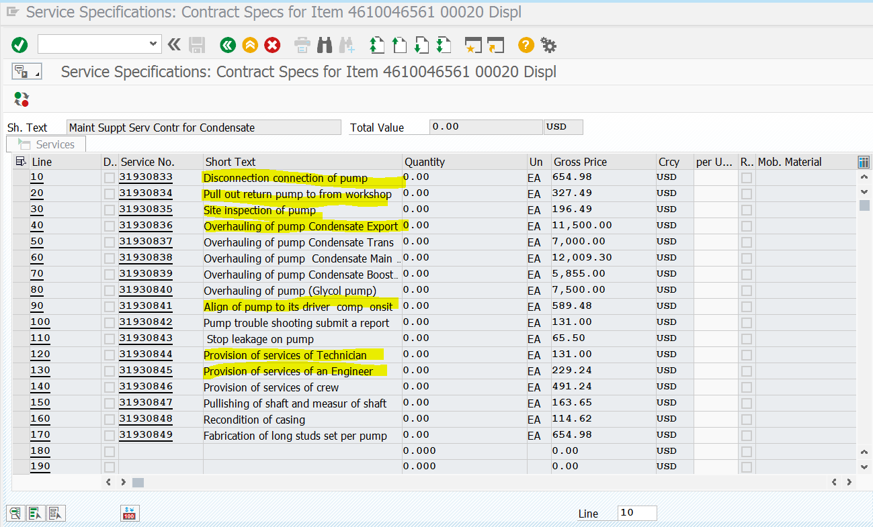

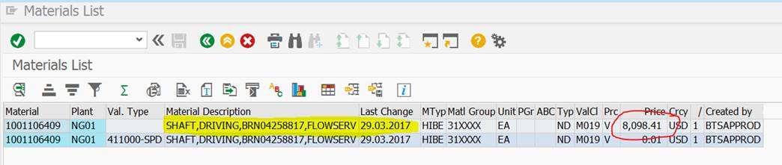

Estimate :Disconnection (654.98)+Pull out(327.49)+site inspection(196.49)+Overhaul (11,500)+pump alignment(589.48)+Provision of services Tech(131X 2 personnel)+provision of services of Engineer(229.24). Services savings: $13,759.68 + Cost of shaft (8,098.41)

**Total Savings=21,858.09**